How to create a Test Case

What is a Test Case?
A Test Case is a scenario/a script to test a specific behavior of the feature you want to test.
It contains multiple Steps, Actions and Controls to perform the scenario.
In the following steps, we will see how to create a Test Case and the specific info and parameters related to a Test Case.

Create a Test Case:
Click on the Test Case menu, then on the TestCase List menu
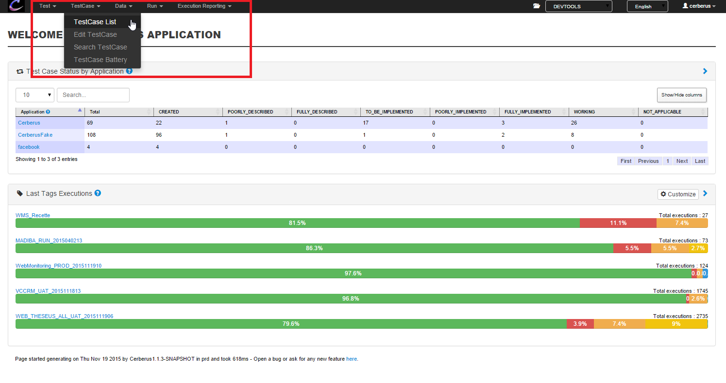
Select the Test in which you want to create the Test Case and click on the “Load” button
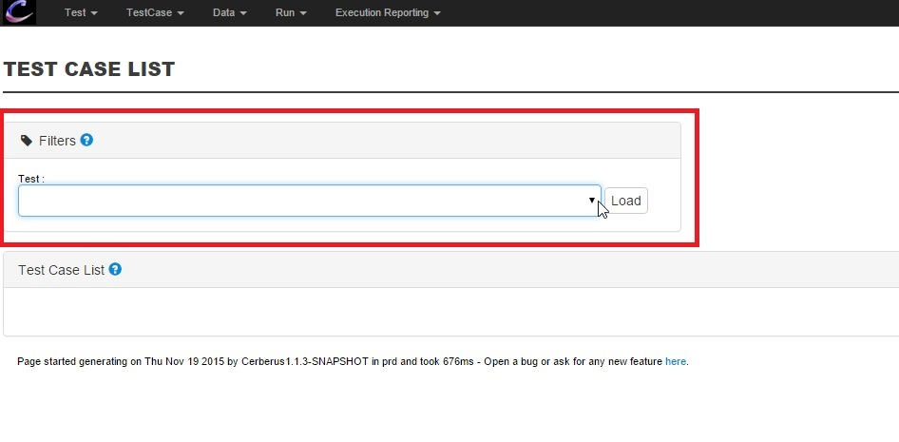
To create your Test Case, click on the “Create Test Case” button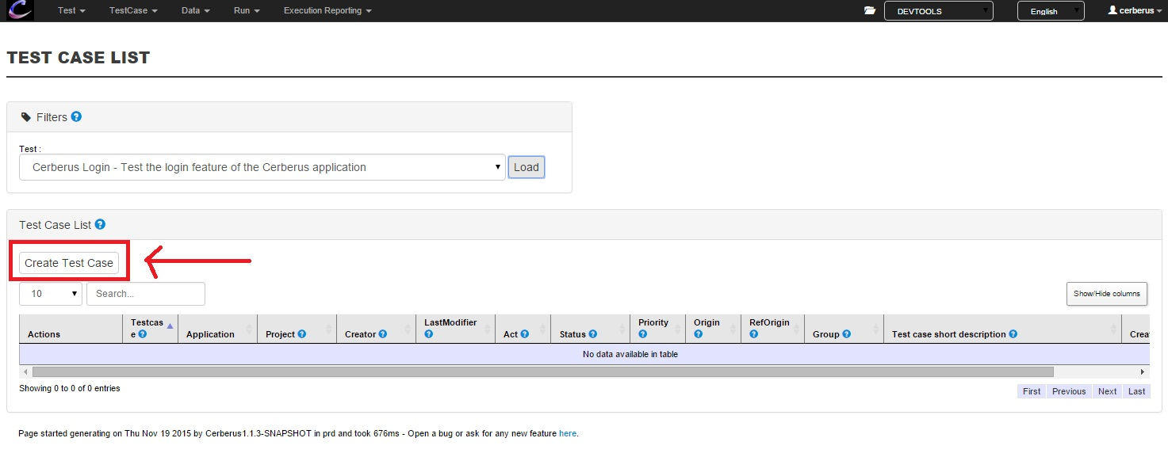
The following pop-in is displayed:
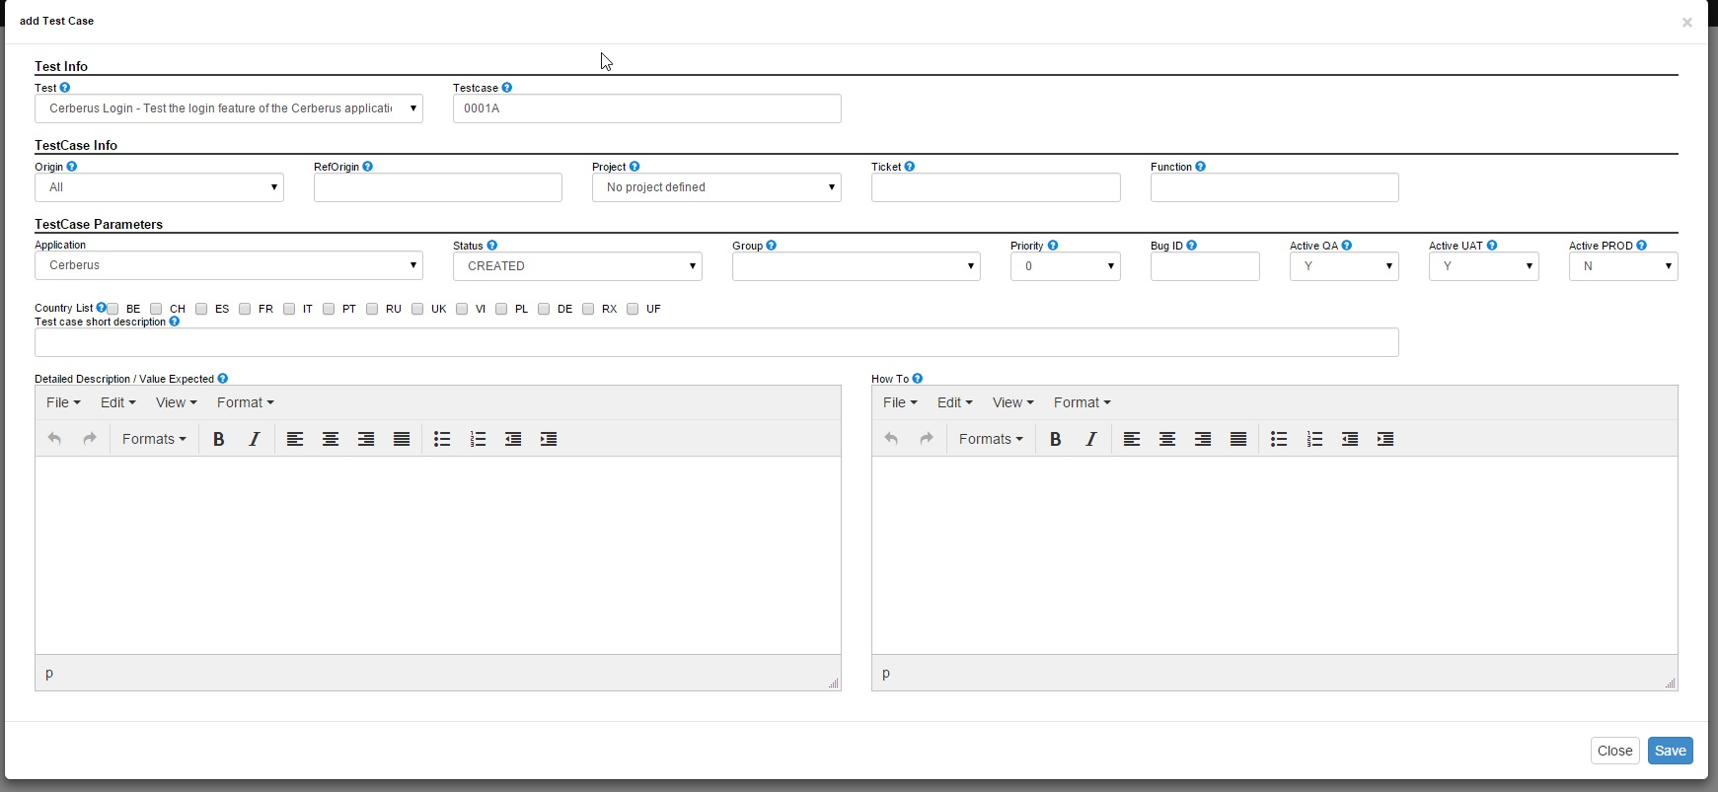
Description of the fields:
Test: The Test in which you want to create the Test Case.
TestCase: The number of the Test Case. It’s pre-generated for you but you can change it if you want.
Origin: This is the country or the team that identified the scenario of the Test Case.
Ref Origin: This is the reference of the Test Case when coming outside from Cerberus
Project: This is the ID of the project that provided the implementation of the Test Case.
Ticket: This is the ticket Number that provided the implementation of the Test Case.
Function: The function of your application that the Test Case is testing
Application: The Application that the Test Case is testing
Status: This is the workflow status of the Test Case implementation
Group: Type of group in which the Test Case is.
Priority: Priority level of the function tested
Active QA: Define if the test is runnable in the QA environment
Active UAT: Define if the test is runnable in the UAT environment
Active PROD: Define if the test is runnable in the PROD environment
Country List: Countries in which the Test Case is runnable
Test Case short Description: This is the short description of your Test Case, it should describe the scenario you are testing.

To save your Test Case, click on the “Save” button.
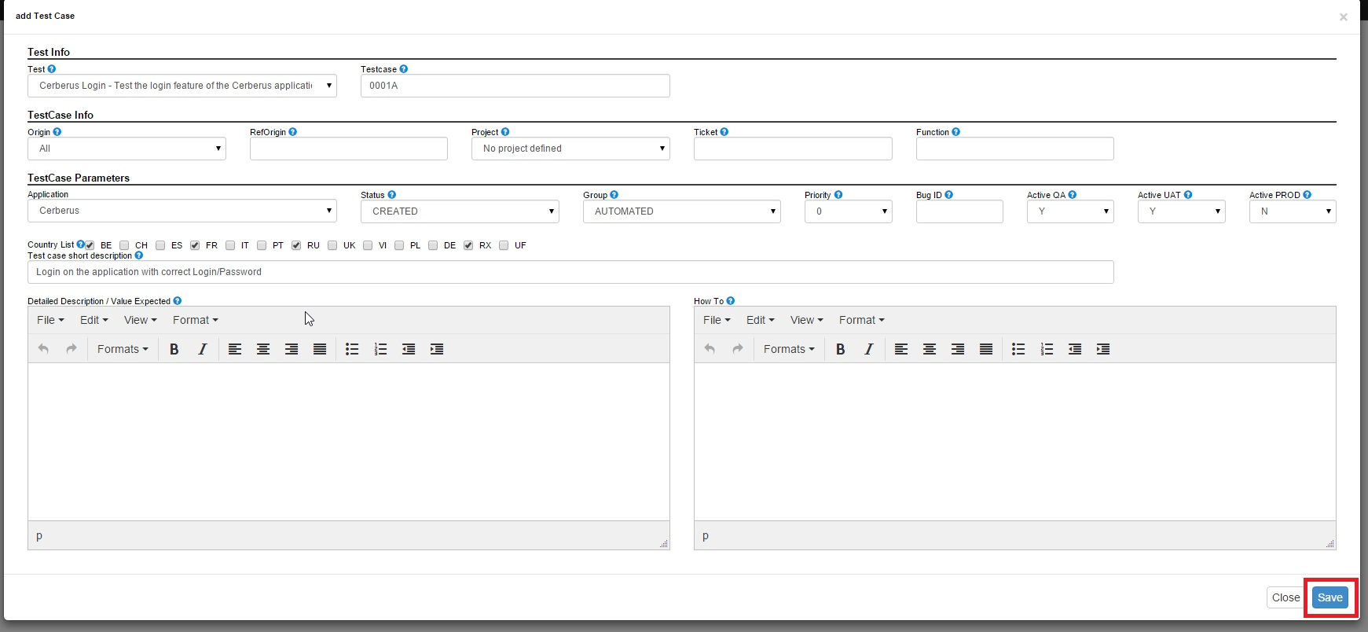

Specific actions:
: Use this button to Edit your Test Case. (If you have the rights to do it)
: Use this button to Delete your Test Case. (If you have the rights to do it)
: Link to the Test Cases Script.

